LANDCARE/BUSHCARE IN BERRY 2019

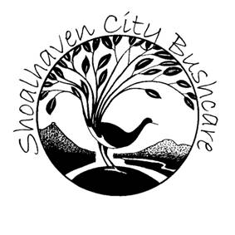

Taking action to prevent and repair degradation of our natural resources,
action which includes restoration of creek and river banks, weed management, the prevention of over clearing of native vegetation and soil erosion, and the planting of appropriate native vegetation.

"To protect our environment and way of life now and for future generations we must carefully manage our land, air, water and biodiversity"
The Landcare Ethic

- Landcare refers to work with private landowners on their land.
- Bushcare refers to work on council owned or managed land and supported by the Shoalhaven City Council’s Bushcare Program.
- Parkcare refers to work in park areas managed by SCC Parks Department

HOW DOES LANDCARE WORK?

- Primarily driven by concerned individuals
- Local groups concerned about local ecological and sustainability issues
- Support/training available from Local, State & Federal Government through grants, and Landcare/Bushcare coordinators who provide advice and encouragement.
- full time SCC Bushcare Coordinator & provides insurance, equipment, materials & technical advice for groups working on Council owned/managed land
- Landcare is an Australia wide community based movement with more than 200 groups in the Illawarra/ South Coast Region
- Each group has a project plan and objectives.
- Berry Landcare is an active member of the Shoalhaven Landcare Association.
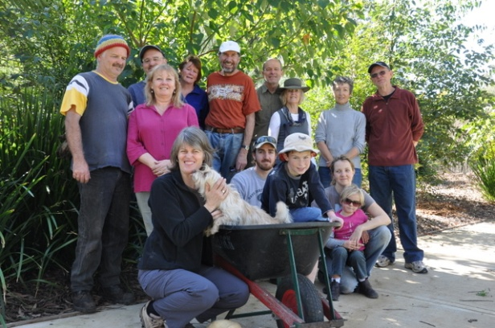 | In 2007, Berry Landcare received awards in the Champions of the Catchment Regional Awards, for Landcare Community Group, and in the Shoalhaven Awards for Outstanding Landcare Group. In 2016, Winner of the Conservation Champion Award, Kiama Electorate Community Recognition Awards
LANDCARE/BUSHCARE IN THE BERRY AREA

In addition to working bees for natural resource management, Berry Landcare organises events, such as displays and talks to raise Community awareness of environmental and ecology issues. Projects include “Plant Local”, a Register of Significant Trees and the Berry Corridor, Escarpment to the Sea, for which a $500,000 grant has been received from the NSW Environmental Trust at the end of 2015, for Berry Landcare in partnership with NSW National Parks Association over a period of 10 years.

Berry Landcare currently has twelve active sites and more than 150 members and volunteers:
- Alexandra St Parkcare:
- Bong Bong Road
- Broughton Vale Common
- Bundewallah Rainforest Reserve
- Camp Quality Park Bushcare
- David Berry Hospital Rainforest Remnant
- Mark Radium Park Parkcare (and the Arboretum of locally indigenous rainforest trees)
- Moeyan Hill Reserve
- Mount Coolangatta
- Princess St Park Parkcare:
- Strongs Road, Jaspers Brush
- Tindalls Lane

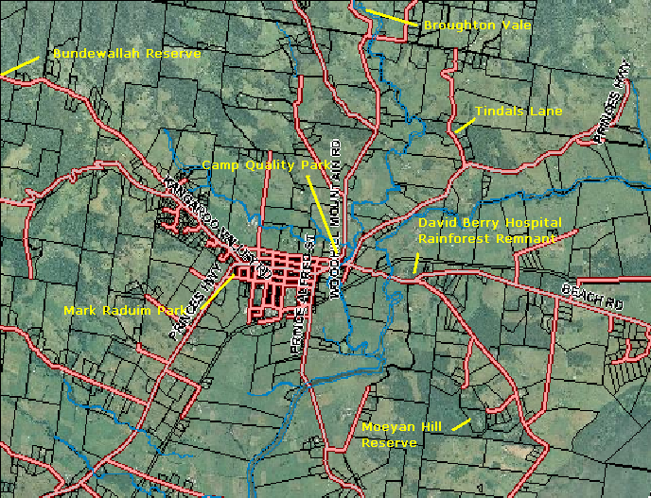

BUNDEWALLAH RESERVE – SUB TROPICAL WONDER
- Site Coordinator: John Clark
- Illawarra Sub Tropical Rainforest Remnant, waterfalls, coastline views. Regeneration of rainforest remnant and restoration of Walking track; SRCMA Bush Incentives grant 2007 for Lantana control and Envirofund Round 9 grant 2007 for Coral Tree removal and riparian restoration
- Supported by Shoalhaven City Council’s Bushcare Program

DAVID BERRY HOSPITAL RAINFOREST REMNANT
- Site Coordinator: Leslie Pigott 4464 3241
- Unique EEC Illawarra subtropical rainforest remnant with wide species band;
- supported by Berry Landcare with weed control and advocacy
- Good support from the Hospital administration

MOEYAN HILL RESERVE
- Site Coordinator: Bill Pigott 4464 3241
- 36 ha reserve with Illawarra Sub Tropical Rainforest and tall open woodland
- One of the original Berry Landcare/Bushcare sites; Remnant Vegetation Management Plan prepared in 1998: High conservation value with wildlife corridor and local biodiversity;
- Supported by Shoalhaven City Council’s Bushcare Program

MARK RADIUM PARK PARKCARE
- Site Coordinator: Sue Seldon
- ‘Arboretum’ of locally indigenous rainforest trees (partnership with the Berry Alliance and Shoalhaven City Council, funding from Shoalhaven Landcare/NLP), started with 5 trees planted in Memory if Rick Farley, co-founder of the Landcare movement, in July 2006

TOWN CREEK PARKCARE GROUPS
- Princess Street Park: Site Coordinator: Terry Oades 4464 3654
- Alexandra Street: Site Coordinator: Gail Paton 4448 7915

TINDALLS LANE SITE
- Site Coordinator: Jim Jefferis
- Local residents in Tindalls Lane work to weeds and maintain the Boundary Rd link between Tindalls Lane and Tulloch Rd.

BROUGHTON VALE SITE
- Site Coordinator: Kelvin Officer
- Weed removal and revegetation along Broughton Mill Creek
- Envirofund Round 9 grant 2007 for Coral Tree removal and riparian restoration

STRONGS ROAD SITE
- Site Coordinator: Ian Parker 4448 6359

BONG BONG ROAD SITE
- Site Coordinator: Julia Woinarski 4464 2084

Camp Quality Reserve
- Site Coordinators: Jeanne Highland and Hugh Sheil
- First major Berry Landcare Site – large amount of community input
- Has attracted significant SCC input for 2006 and 2007 with Section 94 funds

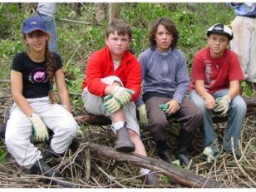 | 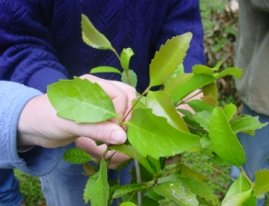 | 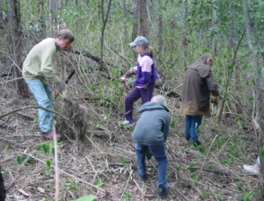 | 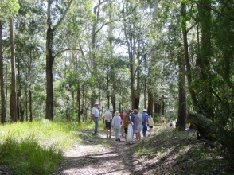
BERRY LANDCARE Inc. Objectives:

- Working to protect our natural environment and prevent and repair degradation of our natural resources, by action which includes:
a) restoration of creek and river banks,
b) weed management,
c) prevention of over clearing of native vegetation and soil erosion,
d) planting of appropriate native vegetation.
e) promotion of the planting of locally indigenous plant varieties
- Engaging members of the Berry Community in educational and fundraising activities, harnessing community skills and creating public awareness.
- Working with the Berry Community to achieve a sustainable and resilient natural environment with vegetation connections supporting the movement of wildlife between the coast and the escarpment.
- Engaging community members in caring for country at Landcare, Bushcare and Parkcare sites, through working bees and other activities
- Sharing information on Natural Resource management and sustainable agriculture
- Establishing appropriate and nurturing existing partnerships with the Berry Alliance, Shoalhaven City Council, Southern Rivers Catchment Management Authority and the Shoalhaven Landcare Association

How you can help?  - Join Berry Landcare  - Don’t throw garden clippings or rubbish in the bush  - Grow local plants in your garden,  - Plant locally indigenous trees  - Avoid growing weedy plants on your property | 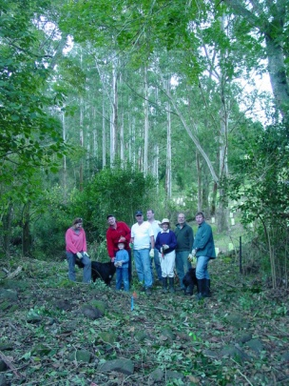
Working bees are generally from 2pm to 4 or 5 pm. (an hour later during summer time)
- Alexandra Street Parkcare: Morning 3rd Friday of the month: Gail Paton 4448 7915.
- Bong Bong Road: morning 2nd Sunday each month: Julia Woinarski 4464 2084.
- Broughton Vale: afternoon 2nd Sunday of the month: Kelvin Officer 0427255417.
- Bundewallah Bushcare: afternoon last Sunday of the month: John Clark 4464 3911.
- Camp Quality Park: Morning, 3rd Sunday: hugh.sheil@realtimecom.com.au or Jeanne Highland 4464 1271.
- David Berry Hospital alternating with Moeyan Hill Reserve: 3rd Saturday of each month.
- Mount Coolangatta: Nola Barker. Mobile 040944-6418, nolajbarker@live.com.au. Time to be advised.
- Mark Radium Park: 9-10am last Friday: Sue Seldon: sueselden@optusnet.com.au
- Princess St. Parkcare: 9-11am last Monday: Terry Oades 4464 3654.
- Tindalls Lane: 2nd Sunday each month (afternoon) Jim Jefferis 4464 2988.
- Others sites as arranged by site coordinators. VOLUNTEERS WELCOME at all sites.

For further information contact berrylandcare@gmail.com or for more on Berry Landcare and late changes to working bee details. http://www.landcare.nsw.gov.au/groups/berry-landcare
- Jim Jefferis on 4464 2988 (Chairman, Tindalls Lane & Boundary Road Link)
- Will Armitage on 44642241 (Vice Chairman) warmitage007@gmail.com
- Julia Woinarski - 4464 2084 (Treasurer & Bong Bong Rd)
- Hugh Sheil (Secretary & Camp Quality Park ) hugh.sheil@realtimecom.com.au
- Bill Pigott -4464 3241 (Membership; Moeyan Hill; Corridor Working Group) wpigott@bigpond.net.au
- Harvey Blue on 4464 1880 (Publicity and Tree ID). harveyblue@ozemail.com.au
- Facebook:http://www.facebook.com/inbox/?tid=1112261026289#/topic.php?uid=251454051294&topic=13306
- Peter Swanson, Shoalhaven Bushcare Coordinator on 4429 3592
  - e-mail: peter.swanson@shoalhaven.nsw.gov.au
  - website: www.shoalhaven.nsw.gov.au and go to Environment
Plant identification service: Please contact Harvey Blue 4464 1880 or Ian Parker, 4448 6359.

